"APPROVED" "AGREED"
______________ __________________
President of the Vice-President of the
RPA "IKO Kyokushinkaikan Federation" RPA "IKO Kyokushinkaikan Federation"
Bukeyev M.E. Kassymov A.M.

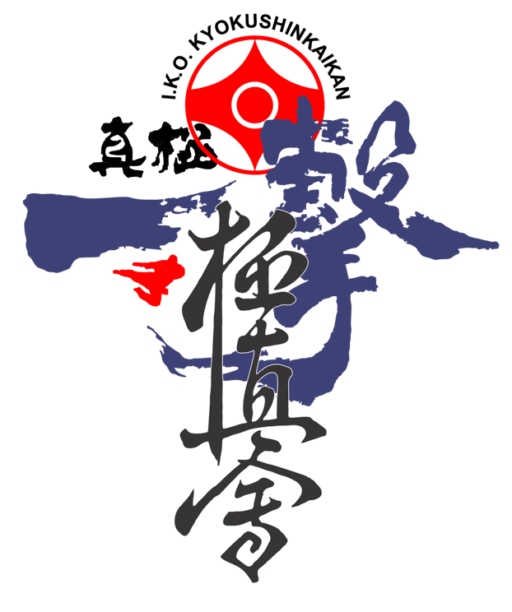

POSITION
ABOUT THE OPEN INTERNATIONAL TOURNAMENT
«CASPIAN GOLDEN CUP -2019» BY KYOKUSHINKAIKAN KARATE
IN THE DISCIPLINE OF KUMITE AMONG BOYS AND GIRLS, JUNIORS,
MEN AND WOMEN.

Aktau city in 2019.

RPA “IKO Kyokushinkaikan Federation”

POSITION
about holding an OPEN INTERNATIONAL TOURNAMENT
«CASPIAN GOLDEN CUP -2019»
ON KYOKUSHINKAIKAN KARATE in the discipline of Kumite among boys and girls, juniors,
men and women.

September 28-29, 2019.
Aktau.
ikokazakhstan@gmail.com
Kazakhstan.

- 1. Goals and objectives

1.1. Popularization of Kyokushinkaikan Karate.
1.2. Strengthening of friendly sports relations between sportsmen of the near abroad.
1.3. Increase the level of sportsmanship.
1.4. Identification of the strongest fighters
1.5. Involve a wide range of young people in systematic sports.

- 2. Place and time

Competitions are held in Aktau on September 28-29, 2019 at the address: 32 md. S/C "Mangystau Arena"
09.00 - the beginning of the competition

- 3. Guide to the international tournament

Chief Judge: Shihan Gorai Katsuhito (8th Dan) / Japan /.
Chief Secretary: Sensei Murat Bukeyev (3 Dan) / Aktau /.
For more information call: + 7-7057888359
or by e-mail ikokazakhstan@gmail.com
The organization of an open international tournament is entrusted to the head of the Mangystau region of the IKO Kyokushinkaikan Federation

- 4. The program of the international tournament

Fri, Sept. 27
from 10-00 to 18-00 weighing the participants. Weighing will take place at the address: (Aktau, 1st md., KSU "Tennis Center")
from 16-00 to 18-00 judicial seminar under Shihan Gorai Katsuhito (8th Dan) / Japan / and Shihan Artur Hovhannisyan (5 dan) /Japan/.
18-00 to 20-00 judical test under Shihan Gorai Katsuhito (8th Dan) / Japan
Sat, 28 September
-09.00 - 12.00 - preliminary fights in the age category from 12-15 years
-12.10 - 13.00 - opening of the tournament.
-13.05 - 17.30 - preliminary, as well as final fights in the age category from 12-15 years
-17.30 - 17.45 - preparation for the prize-giving ceremony.
-17.45 - rewarding, congratulation of winners.
Sn, 29 September
-10.00 - 12.00 - preliminary fights in the age category from 16 years and over
-12.10 - 13.00 - opening of the tournament.
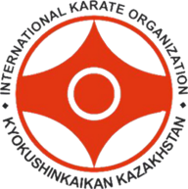
-13.05 - 17.30 - preliminary, as well as final fights in the age category from 16 years and over
-17.30 - 17.45 - preparation for the prize-giving ceremony.
-17.45 - rewarding, congratulation of winners.

- 5. Terms and conditions.
5.1. An open international tournament is held according to the rules of IKO.
5.2. Terms and Conditions:

Weight and age categories |  |  | Competition Regulations
 | Age  (years) | Weight, (kg) | Basic time  (minutes) | Additional  time | Additional  time in the final and semi-final matches | Weighing  (difference) | Extras. time
Boys | 12-13 | -35,-40,-45,+45 | 2 | 1 | 1 | 2 kg | 1
Girls | 12-13 | -40,-45,+45 | 2 | 1 | 1 | 2 kg | 1
Junior (boys) | 14-15 | -50,-55, -60,+60 | 2 | 1 | 1 | 2 kg | 1
Junior (girls) | 14-15 | -50,-55,+55 | 2 | 1 | 1 | 2 kg | 1
Junior (boys) | 16-17 | -55,-60,-65,+65 | 2 | 2 | 1 | 2 kg | 1
Junior (girls) | 16-17 | -50,-55,+55 | 2 | 2 | 1 | 2 kg | 1
Men's | 18 + | -65,-70,-80,+80 | 3 | 2 | 2 | 3 kg | 2
Women | 18 + | -60,-65 | 3 | 2 | 2 | 3 kg | 2
In the event that the opponent does not appear on the tatami for 1 minute, after the name has been announced, the athlete will be considered defeated.
ATTENTION!!! Weight categories can change after the submitted applications due to the number of participants!

Participants of the tournament:
All athletes who are members of IKO Kyokushinkaikan are allowed to participate.
The quantitative composition is unlimited.
Dear leaders and representatives of the teams, for inadequate behavior during the competition from parents, fans, athletes or team representatives to the organizers, judges, measures will be taken in the form of a team withdrawal without refunding the entry fee.

- 6. Equipment.

Athletes:
- Helmet of white color (protective visor at will);
- Shingarh only white, cloth with foam rubber inside, or standard "ichigeki". (Any other leather or "taehkwon-do" styles are NOT ALLOWED);
- Protectors on the shin and lifting the feet for karate only white;
- The inguinal protector is dressed strictly under the mastiffs, if the athlete does not have an inguinal bandage, he will be given 1 minute to eliminate the violation, and also the athlete will be credited with "CHUI";
- Girls, juniors and women, a protective breastplate that does not cover the stomach and the solar plexus in case of violation, will be allocated 1 minute for elimination, as well as counted "CHUI"
- White dogi (kimono) with a hieroglyph on the left breast.
- Belt according to the qualification of the KYU, DAN.
All teams must provide their athletes with the necessary ammunition.
The team must have at least 2 judges for objective refereeing, if the team did not provide the judges, then if you have any controversial points, please do not disturb the referees, as well as the main referee.
Judges:
Official form conforming to the rules of IKO:
- White shirt;
- Dark blue tie;
- Gray trousers.

- 7. Conditions for registration of participants.

Each participant must submit the following documents to the Credentials Committee:
- Birth certificate (original), personal identity or passport original;
- IKO card;
- Application for participation in the championship (original), certified by a doctor;
- Athletes must be at least 12 years old;
- For regions where there is no dispensary to participate in the tournament athlete must submit a medical certificate (for athletes RK);
- Insurance policy (if necessary, the organizers will provide an insurance agent, the estimated price of the insurance policy is 10 USD);
- Receipt from parents (permission to participate in the tournament); appendix №1
- Entry fee is 50 USD.
- During the passage of the weigh-in, provide all the equipment for checking for compliance. If the athlete does not have the necessary equipment for one reason or another, it will be necessary to purchase the missing protection. The organizers will provide such an opportunity to the credentials committee.

- 8. Rewarding.

RPA "IKO Kyokushinkaikan Federation" awards prizewinners of the international tournament for Kyokushinkaikan karate with diplomas, medals, cups.
Prizes are established:
• For the best technique.
• For the shortest fight.
• For the samurai spirit.

Preliminary (with the planned composition of participants) application for the participation of the team in the international tournament must be sent by july 20, 2019 by e-mail to the address: ikokazakhstan@gmail.com

Original applications of the established model for the participation of the team in the international tournament, must be sent by e-mail to the address of ikokazakhstan@gmail.com
until August 28, 2019.

- 9. Accommodation details

Name | Accommodation type |  | Cost for accommodation | Person in charge of accommodation | note
Hotel | For one person | With breakfast | 40$ | Kassymov Azamat Maksutovich +77019996751  Akuntai12@mail.ru | Transport for athletes is held at the expense of the organizers
 | For two people | With breakfast | 50$
hostel | For one person | With breakfast | 15$
Attention: accommodation for branch chief is free of charge!

THIS STATUS IS AN OFFICIAL INVITATION
TO THE INTERNATIONAL TOURNAMENT «CASPIAN GOLDEN CUP -2019»
BY KYOKUSHINKAIKAN KARATE!
OSU!

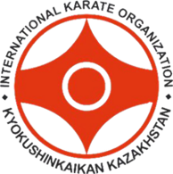
Appendix

Receipt
I _____________________________________________, passport № _____________, issued __________________________, I authorize my son (daughter) ______________________________________________________________________________________ to participate on September 28-29, 2019 in the INTERNATIONAL TOURNAMENT "CASPIAN GOLDEN CUP -2019" on Kyokushinkaikan karate in Aktau at the S/C “Mangystau Arena” address. In case of injuries and their consequences, I will not have any claims to the organizers of the tournament and the coaching staff.

Date:___________________
Painting: ________________

