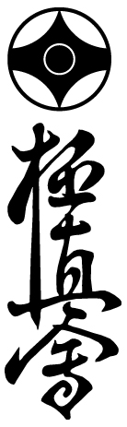

The 32th European Weight Category Karate Championships

European Juniors Karate Championships
European Seniors Karate Championships

MAY 19-20, 2018 - VARNA, BULGARIA

Match duration for Juniors 12-15 years old:
(1) Elimination rounds: 90sec->90sec
(2) Semi Finals and Finals: 90sec->90sec>Weight (3kg)->90sec

Match duration for Juniors 16-17 years old:
(1) Elimination rounds: 2m->2m
(2) Semi Finals and Finals: 2m->2m->Weight (3kg) ->2m

Match duration for Senior: (1) Elimination rounds: 90sec->90sec
(2) Semi Finals and Finals: 90sec->90sec>Weight (3kg)->90sec

Men and Women: (1) Elimination rounds: 2m->2m
(2) From 2nd rounds to Quarter Finals: 2m->2m->2m
(3) Semi Finals and Finals: 3m->2m->2m->Weight (3kg) ->2m

Juniors 12-13 years old (boys and girls)
* Kata: Elimination round--- Pinan-sono-ni
Final for top 4 only---- Gekisai Sho

Juniors 14-17 years old, Men and Women
* Kata: Elimination round--- Gekisai Sho
Final for top 4 only---- They can chose kata. The same as IKO standard kata rules.

OSU!

Emil Kostov
IKO Branch Chief of Bulgaria

