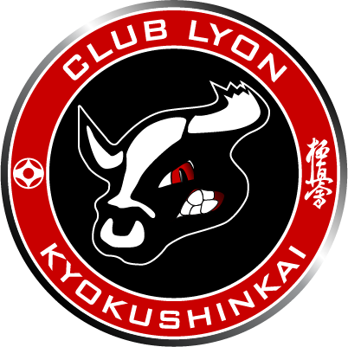
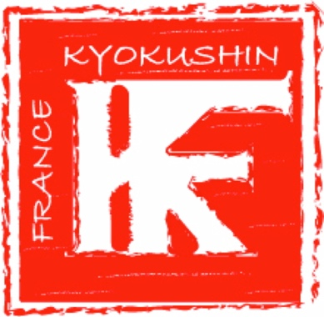

THE 31th EUROPEAN WEIGHT CATEGORY KARATE CHAMPIONSHIPS
EUROPEAN JUNIORS KARATE CHAMPIONSHIPS
EUROPEAN SENIORS KARATE CHAMPIONSHIPS

MAY 20, 21 – LYON, FRANCE

Contents
MAY 20, 21 – LYON, FRANCE 1
Registration 3
Programme 4
May 19, 2017 (Friday) 4
May 20, 2017 (Saturday) – Juniors / Seniors +35 years old 5
May 21, 2017 (Sunday) – Seniors 5
May 22, 2017 (Mondy) 5
Transport 6
Competition 6

Registration

Web registration by IKO Honbu from 27 March and set deadline on 9 April 2017

Programme

May 19, 2017 (Friday)
- From 10h (a.m) to 20h – Registration for all competitors
Hôtel IBIS Lyon La Part Dieu Les Halles
78 rue de Bonnel 69003 Lyon

The competitor must bring :
  - IKO membership card
  - Passport
  - A valid medical certificat
  - Set of protection

All participants and team members of the Championship must have a valid insurance. The organizer does not provide any insurance and does not take responsibility in this area.
All payments must be made directly to the organizer while performing registration or fast check via web site (check-in fast).

- From 17h to 19h – Judge seminar
Hôtel Mercure Lyon Centre Saxe Lafayette
29 rue de Bonnel 69003 Lyon

- 19h – IKO Meeting
Hôtel Mercure Lyon Centre Saxe Lafayette
- ue de Bonnel 69003 Lyon

May 20, 2017 (Saturday) – Juniors / Seniors +35 years old

Halle Stéphane DIAGANA
Rue Victor Schoelcher 69009 Lyon

- From 8h30 (a.m.) to 9h (a.m.) – Judges brieffing
- 9h30 (a.m.) – Start of the competition with Kata
- After Kata, start fight for Juniors and Seniors de +35 years old
- 13h – Opening ceremony (all participant juniors and seniors must be present in dogi).

May 21, 2017 (Sunday) – Seniors

Halle Stéphane DIAGANA
Rue Victor Schoelcher 69009 Lyon

- Start with kata (Men and Women)
- After kata, start fight competition (Men and Women)
- Sayonara Party (limit to 250 persons, price of entry 35€)
Hôtel Mercure Lyon Centre Saxe Lafayette
29 rue de Bonnel 69003 Lyon

May 22, 2017 (Mondy)

Halle Aux Fleurs
66 rue Smith 69002

- From 10h (a.m.) to 12h – Seminar with Kancho Matsui
Price : 50€

Transport

For all competitors, coaches and judges will be provided free transportation from the official hotel to the hall and back to the days Mays 21-22, 2017.

Competition

Tournament is 5€ and open to the public, fans and supporter.

