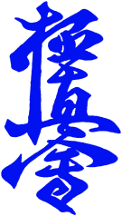
TURKU KYOKUSHIN KARATE TOURNAMENT 2020,
PARTICIPANT PERMIT AND COMMITMENT

Name of Child: .............................................
Date of Birth: .............................................
Team and City: ............................................ Coach/ BC: .....................................

My child has the permission to participate kyokushin tournament in Turku 21.3.2020 (This permission is required from all competitors under 18 years og age)
- In Turku Kyokushin Tournament the rules are held according to Ikokyokushinkaikan (IKO 1) competition rules.
- Kyokushin karate Turku Finland Ry does not take responsibility of any possible injuries during tournament. All participants are required to have their own insurance. (present your insurance certificate during registration).
- The organizer of the tournament will take photos and videos during tournament and they have permission to use them for promotional purposes such as in official websites, facebook and other possible media related.

Signature of child:----------------------------

Name of Parent or guardian:----------------------------

Signature of Parent or guardian:----------------------------

Date: -------/------ /2020 Place: ---------------

