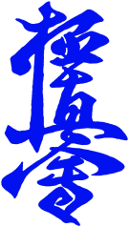
TURKU KYOKUSHIN KARATE TOURNAMENT 2020,
COMMITMENT

Name: .............................................
Date of Birth: .............................................
Team and City: ............................................. Coach / BC: .....................................

I participate to kyokushin karate tournament in Turku 21.3.2020
- In Turku Kyokushin Tournament the rules are held according to kyokushinkaikan (IKO 1) competition rules.
- Kyokushin karate Turku Finland Ry does not take responsibility of any possible injuries during tournament. All participants are required to have their own insurance. (present your insurance certificate during registration).
- The organizer of the tournament will take photos and videos during tournament and they have permission to use them for promotional purposes such as in official websites, facebook and other possible media related.

Signature:----------------------------

Date: -------/------ /2020 Place: ----------------

