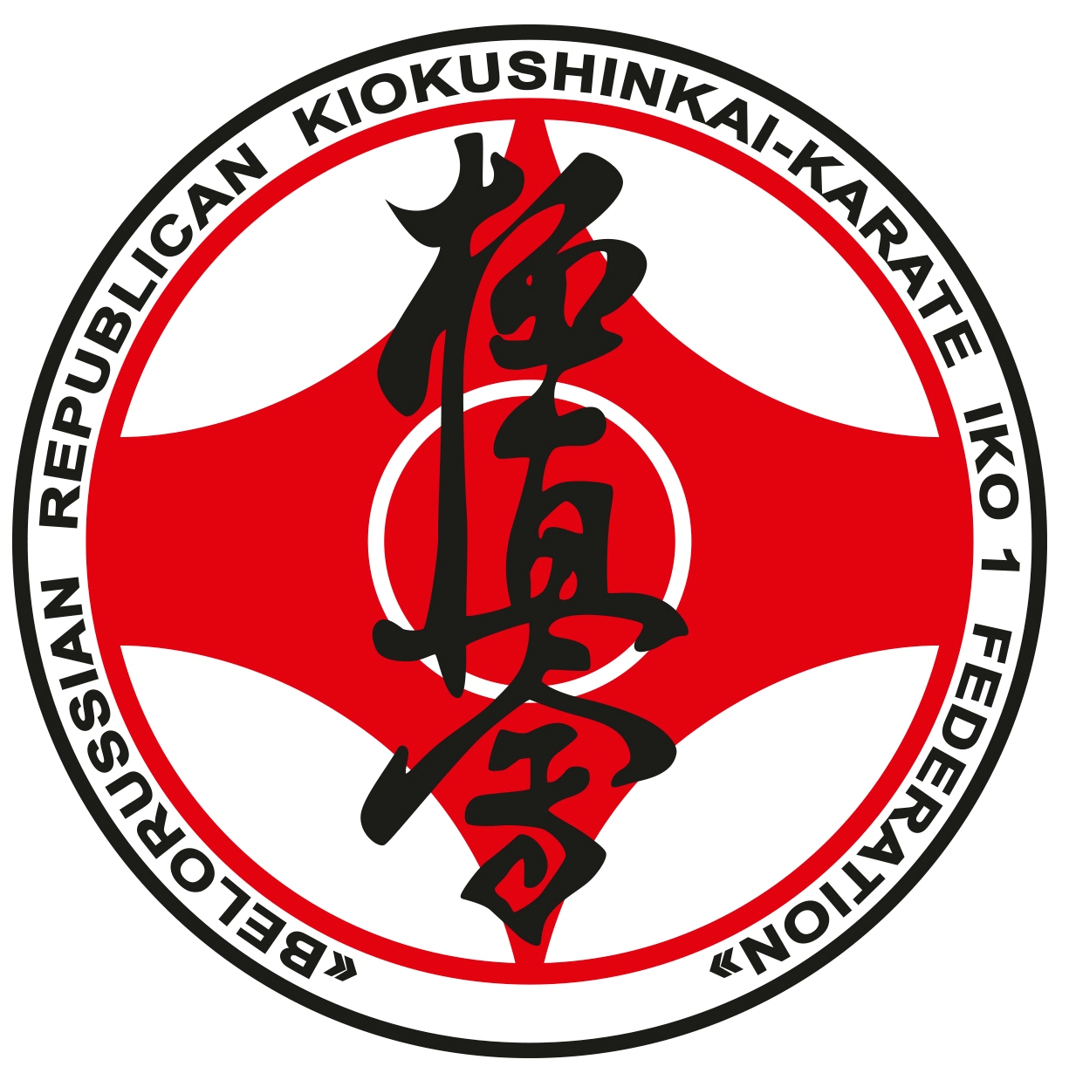

REGULATIONS
OF CARRYING OUT THE OPEN INTERNATIONAL TOURNAMENT
IN KIOKUSHINKAI KARATE (IKO)
AMONG CHILDREN AND JUNIORS (age 8-17),
AMONG MEN AND WOMEN
IN KUMITE SECTION
«Belarus Open Cup»

14-15th of April, 2018
MINSK

1. Purpose and Mission of the Tournament:
purpose:
- rating of the strongest sportsmen in kumite section;
- development and popularization of Kiokushinkai karate (IKO) in Belarus;
- establishing and development of international relationship between Belarussian sportsmen and sportsmen from another countries.

missions:
- popularization of Kiokushinkai karate (IKO) in Republic of Belarus;
- popularization of sport and healthy way of living;
- increasing of participants` abilities, skills and sports proficiency level;
- organization of populations’ leisure.

2. Organization and Financing of the Tournament:
2.1. The Tournament is organized directly by the public association “Belarussian Republican Federation Kiokushinkai karate “IKO-1.
2.2. The public association “Belarussian Republican Federation Kiokushinkai karate “IKO-1” awarders the winners and prizewinners by diplomas and valuable prizes, medals, pays the lease of the Tournament place.
2.3. The public association “Belarussian Republican Federation Kiokushinkai karate “IKO-1” incurs expenses on medical services.
2.4. The expenses connected with sending of the participants, the heads of delegations, the trainers and the judges as a part of the delegation on competitions (fare, placing, food, daily allowances, etc.), bear the organizations sending them.
2.5. For covering the Tournament costs, extrabudgetary sources of financing can be used.
2.6. Each participant`s voluntary contribution constitutes:
- 50 BLR – kumite
- 40 BLR – kata
- 70 BLR – kumite & kata
- 50$ - technical training workshop of Shihan Goraya

3. Place, Date and Time of carrying out:
April, 14th (Saturday):
12:00 – 18:00 - registration and weighing of participants;
17:00 – 19:00 - a technical seminar under the direction of Shihan Gorai;
19:30 – 21:00 - a judicial seminar under the direction of Shihan Gorai
(obligatory for all judges) with the judicial category attestation;
Venue: Minsk, Independence Avenue, 196, (sports complex «Uruchie»).

April, 15th (Sunday):
09:00 – Tournament participants and judges gathering;
10:00 – Grand opening;
10:30 – competition in kata;
12:00 – preliminary combats;
13:30 – 14:00 - timeout;
14:00 – 18:00 - continuation of combats;
18:00 – 19:00 - rewarding and championship closing, photographing;
Venue: Minsk, Independence Avenue, 196, (sports complex «Uruchie»).

4. Requirements for the competitors and the conditions of the right of entrance:
4.1. The conditions governing the admission of organizations and athletes to compete:
4.1.1. The teams from Belarus, foreign countries of international organization IKO are entitled to participate at the competition;
4.2. The consist of the participants and the strength of the team: to participate in the competitions allowed athletes in kata section from the age of 8 years, in kumite section from the age of 9 years. In order to participate in sports competitions the athlete must reach the age before the day of the competition (the competition day - the day of the Credentials Committee).
4.2.1. To compete in kumite allowed athletes who have qualification not below 9 Kyu, 8 and older age with experience in competitions.
4.2.2. the strength of the team:
- official representative of the team;
- athletes (kumite) - without restrictions;
- team doctor (if there is one);
- judges - at least one judge from the team with the experience in judging the competition at that level. Each judge at the Tournament should have: black or gray pants, a white shirt with short sleeve, an IKO-tie, or red tie and a whistle.
The original applications for participation and other necessary documents are submitted to the credentials committee.
The application should contain:
• organization name;
• full name of the participant (in full);
• full date of birth;
• exact weight;
• qualification of the athlete Kyu (Dan);
• IKO card number;
• name and surname of the trainer.
The original of the application for the participation in the tournament must be signed and stamped by the head of the club, federation, signed by a doctor, stamped by clinic and personal seal of the doctor, who is obliged to assure the admission of each athlete. The number of eligible athletes in the order must be indicated in words.

4.3 Each competitor at the time of the passage of the Credentials Committee must have the following documents:
- passport or birth certificate (for children under 14 years);
- the membership card of IKO;
- the insurance, valid at the time of the competition (from the 13th till 16th of April 2018) + time of the road in both directions (the original);
- the team application, certified by medical-sports clinic (Appendix № 2);
- a written permission from the parents to participate - for all participants (Appendix № 1);
- the allowance of sports doctor to participate in the competition and it must be in personal command application with the round stamp and the seal of the sports clinic affixed no later than 10 days at the time of the competition.

4.4. Each participant who has been admitted to the competition must have:
- pure white dogi with a belt corresponding to qualification of the athlete;
- individual sink for the groin obligatory for every category;
- body protection for 9-11 years old kids (provided by the Tournament organizers);
- breastplate of the established sample by IKO - for girls and juniors;
- shin protectors and the rise of the foot - for all participants under 17 years old inclusive;

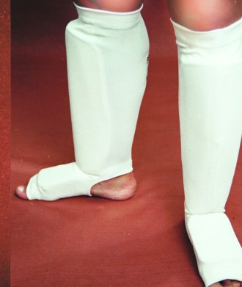

- mitts (shinguards) - for all participants;
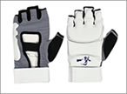

- helmet – for all participants from 9 to 17 years;
- helmet for 9 years old kids obligatory shut, with face protection (provided by the Tournament organizers);
- cap (protector of the oral cavity) - on request, unless the athlete wears braces.

ATTENTION!
All protective equipment must be individually, for each participant!

5. Age groups and weight categories in kumite:
5.1. under 17 years
Age  Boys - youth | Weight class, kg
9 years |  | under 30 kg | under 35 kg | under 40 kg | above 40 kg
10-11 years | under 30 kg | under 35 kg | under 40 kg | under 45 kg | ab. 45
12-13 years | under 40 kg | under 45 kg | under 50 kg | under 55 kg | ab. 55
14-15 years | under 50 kg | under 55 kg | under 60 kg | under 65 kg | ab. 65
16-17 years | under 60 kg | under 65 kg | under 70 kg | under 75 kg | ab. 75
Girls - teenagers | Definition of weight will be made after receiving their applications.
men:
under 70 kg, under 80 kg, under 90 kg, above 90 kg
veterans: categories will be formed after receiving their applications.
women:
under 60 kg, above 60 kg

KATA:
In kata competition there take part boys, girls, young men and girls, junior men and girls separately within next categories:
- boys (8-9 years)
- girls (8-9 years)
- boys (10-11 years)
- girls (10-11 years)
- young men (12-13 years)
- young girls (12-13 years)
- junior men (14-15 years)
- junior girls (14-15 years)
- junior men (16-17 years)
- junior girls (16-17 years)

  - sportsmen participating in competition must have qualification of 9 Kyu and higher.
5.3. changes of weight categories after receiving of applications are possible.

6. Rules of the competition:

6.1. The tournament is spent according to the international rules of Kiokushinkaikan karate - IKO (in kumite section).
6.2. Definition of Winners:
- competition is spent on quitting-after-defeat system, fights for the 3rd place will be carried out.

7. Regulation of fights (kumite, kata)

7.1 Kumite
Children 9-11 years
Qualifying fights: 1.5 minutes. (90 seconds) + 1 min. + Weighting (difference in weight should be 1 kg or more) + 1 min.
Semifinal and final fights: 1.5 minutes. (90 seconds) + 1 min. + Weighting (difference in weight should be 1 kg or more) + 1 min.

Boys and girls 12-13 years old:
Qualifying fights: 1.5 minutes. (90 seconds) + 1 min. + Weighting (the difference in weight is 2 kg and more) + 1 min.
Semifinal and final fights: 1.5 minutes. (90 seconds) + 1 min. + Weighting (the difference in weight is 2 kg and more) + 1 min.

Boys and girls 14-15 years old:
Qualifying fights: 2 minutes + 1 min. + Weighting (the difference in weight is 2 kg and more) + 1 min.
Semifinal and final fights: 2 minutes + 2 min. + Weighting (the difference in weight is 2 kg and more) + 1 min.

Juniors and juniors 16-17 years old; men and women:
Qualifying fights: 2 minutes + 2 min. + Weighting (difference in weight should be 3 kg or more) + 1 min.
Semifinal and final fights: 2 minutes + 2 min. + Weighting (difference in weight should be 3 kg or more) + 2 min.

7.2 Kata. Kata competition is going to be carried out in two stages:

1st stage – required program:

8-9 years - Taikyoku Sono Ichi (1)

10-11 years - Taikyoku Sono San (3)

12-13 years - Pinan Sono Ni (2)

14-15, 16-17 years - Gekisai Sho

2nd stage – voluntary program:
- 8-9 years old, 10-11 years old, 12-17 years old participants will have to perform choosingly 1 complex kata from the list below:

8-9 years - Taikyoku Sono San (3), Pinan Sono Ichi (1)

10-11 years - Pinan Sono Ichi (1), Pinan Sono Ni (2), Pinan Sono San (3), Pinan Sono Yon (4), Pinan Sono Go (5);

12-13 years - Pinan Sono Yon (4), Pinan Sono Go (5),Tsuki No Kata, Gekisai Sho;

14-15 years - Tsuki No Kata, Saifa, Gekisai Dai, Seienchin;

16-17 years - Saifa, Seienchin, Seipai, Kanku, Sushiho.

To the 2nd stage are admitted 4-6 sportsmen who get maximum points during 1st stage of the competition in kata.

Prize-winners of the competition (accordingly 1st, 2nd, 3rd places) are participants who get maximum points during 2nd stage of the competition in kata.

To define the order of competitors` performing the sortation takes place before the 1st stage of the competition in kata. On the 2nd stage the order of performing depends on general quantity of points after the 1st stage. The one who gets minimum points performs at first. The one who gets maximum points performs at last.

8. Refereeing:
Chairman of the organizing committee – Markach Igar
The head-judge – Maksimau Vasili

9. Award
9.1. the winners of the competition (1-3 places) will be awarded with cups, medals and diplomas of corresponding degrees.
9.2. Additionally, prizes can be established by sponsors and other organizations.

10. Applications for participation:
10.1. preliminary applications must be submitted until March 15, 2018.

10.2 the final applications will be accepted until March 30, 2018 at the address:
Belarus, Grodno, Oginsky str, 34-97; tel: 8 0152-67-12-99; +37529 7894972; +375293960812
e-mail: ikobars@mail.ru, markach_igor@mail.ru,

after 23.00 30.03.2018 applications will not be accepted. The bullets of competition will be posted on the website OO BPFKK “IKO 1”: www.kyokushin-iko.by
10.3 Incorrectly issued and out of time submitted applications are not accepted. The changes in the bullets after their publication should not be made !!!
10.4. The application should be printed on the form of association (club) and contain the following data – see Appendix №2.
10.5. Please inform in advance about: hotel (if needed), number of visitors, other demands.

Appendix №1

To Ch. judge competitions Maksimau W.W.
From ___________________________________
(Full father’s name)
Passport number ________№_______________
Authority and date of issue _________________
______________________________________
From __________________________________
(Full mother’s name)
Passport number ________№_______________
Authority and date of issue _________________
______________________________________

STATEMENT

We ask you to allow our sun (daughter)

Full name
date of birth ________________________

to participate at the competition «Open International Tournament in Kyokushin Karate (IKO) «Belarus Open Cup» among children, boys and girls, juniors, men and women», which will be held April 15, 2018, in Minsk, Independence Avenue, 196, (sports complex «Uruchie»).
In case of our child injuries and their consequences, as well as other adverse effects, while participating in the competition, including as a result of the use permitted or not permitted by the rules of the competition equipment, and / or when in the rooms where the competition take place, or you prepare for this competition, will not have any claims to the chief judge, the organizers of the tournament, the coaching staff and the owners of the premises in which the competition is held.

With the rules of competition in Kiokushinkai were introduced, fully aware that Kyokushinkai Karate is contact combat, and we understand the possibility of injury to our child and other adverse effects.

_______________________________ _____________________________
Full name (with his own hand) signature

________________________________________________ _____________________________
Full name (with her own hand) signature

Appendix №2

APPLICATION

On participation in the «Open International Tournament in Kyokushin Karate «Belarus Open Cup»

Carrying out date April 15th 2018, Minsk, sports complex «Uruchie».

Country ____________________________________________________________________

Full name of organization _________________________________________________________

Branch-chief _____________________________________________

Contact number< e-mail _____________________________________________________________

№ | Name  of the participant | Date  of birth | Age | Weight (kg) | Qualification,  Kyu (Dan) | Instructor | City | Number card IKO | Doctor`s admission
1
2
3

Totally sportsmen admitted ____________________________________________________________

Doctor (signature ) __________________________________________________________________

Stamp, signature of the head of Sport Clinic ______________________________________________

The head of organization (federation, club) ______________________________________________

A full date of birth has to be obligatory noted in the Application.

Please apply in accordance with the requirements of this Regulation and by increasing age and weight categories !!!

